**DAY 2 TASK:**

Task 1:

Index.html

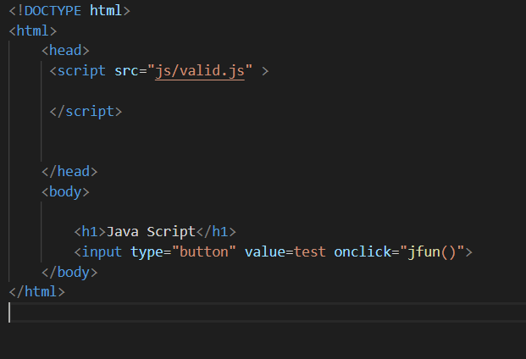

Valid.js

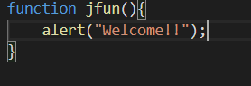

TASK 2:

Form1.html

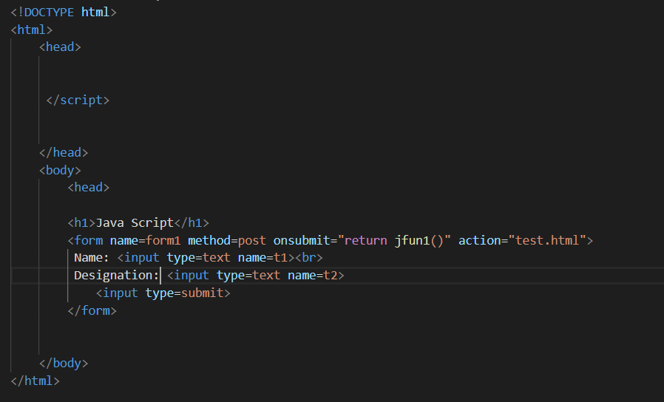

Test.html

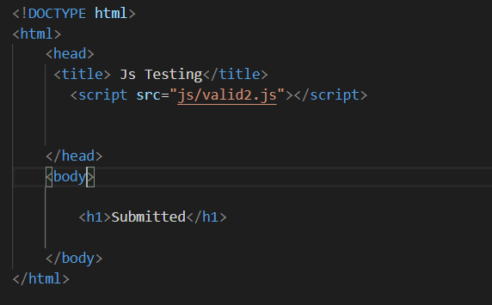

Valid2.js

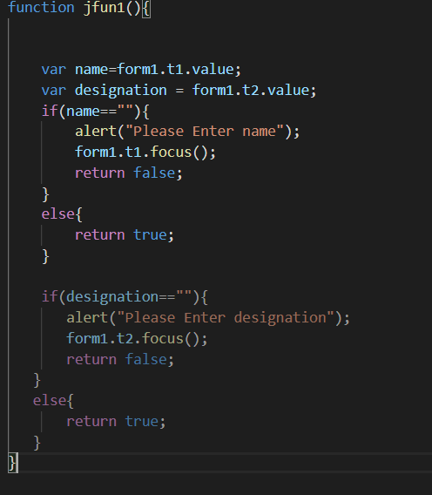

Mongodb Task:

